### RESUME BUILDER

**A MINI PROJECT REPORT**

*Submitted by*

Menta Lakshmi Sathwika (111720202023)

Kommuri Venkata Sai Poojitha (111720202018)

***In partial fulfillment for the award of the***

***degree of***

### BACHELOR OF TECHNOLOGY

**IN**

### COMPUTER SCIENCE AND BUSINESS SYSTEMS

**R.M.K. ENGINEERING COLLEGE**

## (An Autonomous Institution)

### R.S.M. Nagar, Kavaraipettai-601 206



**November 2022**

**R.M.K. ENGINEERING COLLEGE (An Autonomous Institution)**

**R.S.M. Nagar, Kavaraipettai-601 206**

# BONAFIDE CERTIFICATE

Certified that this project report **“Resume Builder”** is the bonafide work of **Menta Lakshmi Sathwika (111720202023), Kommuri Venkata Sai Poojitha (111720202018)**who carried out the **20CB511 Mini Project** work under my supervision**.**

### SIGNATURE SIGNATURE

**Dr.K.Chidambarathanu, M.E.,Ph.D., Dr.K.Chindambarathanu ,M.E.,Ph.D., Professor and Head Supervisor**

Department of Computer Science and Professor and Head

Business Systems Department of Computer Science and

R.M.K. Engineering College Business Systems

R.S.M. Nagar, Kavaraipettai, R.M.K. Engineering College

Tiruvallur District – 601206 R.S.M. Nagar, Kavaraipettai, Tiruvallur District - 601206

Submitted for the Project Viva –Voce held on at **R.M.K.**

**Engineering College,** Kavaraipettai, Tiruvallur District– 601206.

### INTERNAL EXAMINER

**ACKNOWLEDGEMENT**

We earnestly portray our sincere gratitude and regard to our beloved **Chairman Shri. R. S. Munirathinam, our Vice Chairman, Shri. R. M. Kishore** and **our Director, Shri. R. Jyothi Naidu,** for the interest and affection shown towards us throughout the course.

We convey our sincere thanks to our **Principal**, **Dr. K. A. Mohamed Junaid,** for being the source of inspiration in this college.

We reveal our sincere thanks to our **Professor and Head of the Department, Computer Science and Business Systems, Dr. K. Chidambarathanu,** for his commendable support and encouragement for the completion of our project.

We would like to express our sincere gratitude for our Mini Project Coordinators **Ms. S. Jhansi Ida Assistant Professor, Ms. C. Indhumathi Assistant Professor and Mr. B. Jayaram Assistant Professor** and project guide **Dr. K. Chidambarathanu, Head Of The Department** for their valuable suggestions towards the successful completion for this project in a global manner.

We take this opportunity to extend our thanks to all faculty members of Department of Computer Science and Business Systems, parents and friends for all that they meant to us during the crucial time of the completion of our project.

### ABSTRACT

An online resume builder is software developed to simplify the task of creating a resume for individuals. The application provides an effective means of designing desired resume in fact a professional looking resume. The system is flexible to be used and reduces the need of thinking and designing an appropriate resume according to qualifications. Usually individuals get confused while creating a resume especially for a novice person such as graduate students. They don’t get a clear idea of what things and information must be included in a resume.

Hence the system is developed to provide them an easy way for creating a professional looking resume. This project is user-friendly and requires minimum human intervention. Individuals just have to fill up a form that specifies questions from all required fields such as personal questions, educational, qualities, interest, skills and so on. The answers provided by the users are stored and the system automatically generates a well structured resume.

The resume builder application made in Django helps to make impressive resumes easily within a few minutes. Building a resume with no help would be a difficult task like deciding layout, text, display necessary field, etc.

So to overcome these difficulties, we came up with a web resume builder that takes basic information such as name, email address, mobile number, address, some skills, past experience etc. of the aspirant required when applying for a job. It provides professional resumes, instantly generated by the resume builder.

The important aim of this project to help employees to land their dream job with the perfect resumes. The forms for the resume builder are done using crispy forms.

## TABLE OF CONTENTS

|  |  |  |
| --- | --- | --- |
| **CHAPTER** | **TITLE** | **PAGE NO** |
|  | **ABSTRACT** | 4 |
|  | **LIST OF FIGURES** |  |
| **1** | **INTRODUCTION** |  |
|  | 1.1 Introduction | 6-7 |
|  | 1.2 Literature Review | 8 |
| **2** | **SYSTEM ANALYSIS** |  |
|  | 2.1 Existing System | 9 |
|  | 2.2 Proposed System | 9 |
|  | 2.3 Feasibility Study | 10-11 |
|  |  |  |
| **3** | **SYSTEM REQUIREMENTS SPECIFICATION** | |
|  | 3.1 System requirement and specification | 12 |
|  |  |  |
|  |  |  |
| **4** | **SYSTEM DESIGN** |  |
|  | 4.1 UML Diagrams | 13-16 |
| **5** | **IMPLEMENTATION**  5.1 Module & Description | 17 |
| **6**  **7** | **SYSTEM TESTING**  6.1 Test Cases  **CONCLUSION**  **REFERENCES**  **SAMPLE CODING**  **SCREENSHOTS** | 18  19  20  21-22  23-24 |
|  |  |  |

# CHAPTER-1

**INTRODUCTION**

### 1.1 INTRODUCTION

A resume is a document used by individuals to present their background and skill sets. A resume also spelled resume or resume also called Curriculum Vitae or (CV). A document that has a brief summary or listing about relevant education and experience. The CV is typically the first item that a potential user encounters regarding the job seeker and is mostly used for screening an applicant’s which is often followed by an interview, while seeking employment in the job search process and well-designed resume. The Resume Builder will help user build his/her personal advertisement through Resume Builder system develop a resume builder with job placement system. Many large employers use electronic resume processing systems to handle large number of resumes. Job portal advertisement may direct applicants to email his resume to their company or visit their website and submit a resume in electronic format.

In recent years, there has been continuing trend among youths to pursue higher education in their zeal to become highly qualified and skilled. The new technologies, specially, an internet has made a huge impact on knowledge management and information dissemination in education. In many organizations including universities, the web portal is knowledge - management system is among most popular topics. Universities have been at the forefront of website development, which further led to the development of the web portals to provide more useful links to information resources. Portals have different applications or services to solve various problems. One of the aims of web portals is to allow information access and sharing over the Internet. For e.g., in a university, the new students in the faculty need access to information resources to select different courses and to decide on the different areas and majors available, in the faculty.

This need can be addressed through the knowledge portal which should contain appropriate data about the Requirements of the students and user. The increased number of jobless youths and graduates has become one of the serious issue existing both in the developing and developed countries, today. The Internet has changed the way of looking for an employment, through the development of online job portals. A job portal is a type of web portal that provides an efficient way for searching the Internet or the web for vacant job positions available. This research will go through various types of web/job portals but will, in exact look, at job portals as a knowledge management system based on a standard framework.

An online resume builder is a software developed to simplify the task of creating a resume for individuals. The application provides an effective means of designing desired resume in fact a professional looking resume. The system is flexible to be used and reduces the need of thinking and designing an appropriate resume according to qualifications. Usually individuals get confused while creating a resume especially for a novice person such as graduate students. They don’t get a clear idea of what things and information must be included in a resume. Hence the system is developed to provide them an easy way for creating a professional looking resume.

This project is user-friendly and requires minimum human intervention. Individuals just have to fill up a form that specifies questions from all required fields such as personal questions, educational, qualities, interest, skills and so on. The answers provided by the users are stored and the system automatically generates a well structured resume. Users have option to create resume in any format and file.

### Purpose

Purpose of Online Resume Builder is to provide a way to the customers to design their resumes.

1. Creating resumes online.
2. Customizing the look and details.

### Objectives:

The first step is gathering primary details of user for resume generation. After gathering all details from user, system will generate user’s CV .

### Architecture:

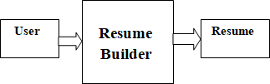

**1.2 LITERATURE REVIEW**

Compared with an application form, job applicants can choose what information to include in their resumes. Some of the options for categories to include are: (a) personal information; (b) personal opening, job objective, career objective, and summary of qualifications; (c) education; (d) work experience; (e) references; (f) scholarships, awards, and honors; (g) hobbies, interests, and extracurricular activities; and

(h) willingness to relocate and travel. Next, the empirical research literature regarding the information that should be included in the resume for each of the aforementioned categories is reviewed.

A large and well-established body of research has suggested that the applicant’s name, address, and phone number should definitely be included in the resume (Hornsby & Smith, 1995; Hutchinson, 1984; Hutchinson & Brefka, 1997; Mansfield, 1976; Wells, Spinks, & Hargrave, 1981). Although not focused on stylistic resume issues, a recent study by Burns, Christiansen, Morris, Periard, and Coaster (2014) has provided support for the inclusion of a school email address over a personal email address as their sample of human resource professionals provided more favorable judgments for resumes that included email addresses containing “.edu”.

The advice to include a school email address over a personal email address is especially applicable for student applicants and recent graduates but may also have implications for additional

applicants. Specifically, future research should address whether more professional email addresses (e.g., givenname.surname@emailprovider.com) are rated more favorably than less professional email addresses.

Although recent research has provided support for the notion that there is no need for a personal opening in a resume (Burns et al., 2014), including a job objective and/or a career objective has traditionally been found to be important information to include in a resume (Harcourt & Krizan, 1989; Harcourt, Krizan, & Merrier, 1991; Hornsby & Smith, 1995; Hutchinson, 1984; Hutchinson & Brefka, 1997; Schramm & Dortch, 1991). Harcourt and colleagues’ (1991) sample of 212 campus recruiters demonstrated a preference for a career objective over a job objective or a combined career and job objective. However, future research is needed to more conclusively demonstrate the impact of including a career objective, a job objective, or a combined career and job objective especially considering the technological advancements since some of this research was conducted. Lastly, a summary of qualifications may also be important to include in a resume (Harcourt & Krizan, 1989; Harcourt et al., 1991); however, future research is also needed to determine whether including a summary of qualifications is effective if a career objective, a job objective, or a combined career and job objective has already been included.

# CHAPTER-2 SYSTEM ANALYSIS

### EXISTING SYSTEM

If someone wants to make his/her resume, then he/she have to look for every single detail such as formatting, alignment, designs, patterns. So, it is a very complex process and thus, the productivity of the resume also decreases. The existing system is very complex and making resume via word files and excels is a tough task. Sometimes, while making a resume, a person ends up forgetting some vry crucial information while going through all these designs and formats.

### Disadvantages

* Have much work and not convenient for users.
* Resume not looks professional

### PROPOSED SYSTEM PROPOSED SYSTEM

In the proposed Online resume builder, a person has to only fill the questionnaire asked by the online platform. All the other alignments and formats of the resume are being directly taken care of by the system. Even, the final resume which came out is very professional as per the industry requirement and the candidate can download the resume as per the file format he/she requires. This is avoiding need of putting manual effort for creating resume.

### Advantages

1. Provides instant resume to individuals.
2. Reduces work and is convenient for users.
3. Provides quick access and is affordable

4. The system saves time and reduces human efforts.

### 2.3.FEASIBILITY STUDY

The feasibility of the project is analyzed in this phase and business proposal is put forth with a very general plan for the project and some cost estimates. During system analysis the feasibility study of the proposed system is to be carried out. This is to ensure that the proposed system is not a burden to the company. For feasibility analysis, some understanding of the major requirements for the system is essential.

Three key considerations involved in the feasibility analysis are,

### ECONOMICAL FEASIBILITY

* **TECHNICAL FEASIBILITY**

### SOCIAL FEASIBILITY ECONOMICAL FEASIBILITY

This study is carried out to check the economic impact that the system will have on the organization. The amount of fund that the company can pour into the research and development of the system is limited. The expenditures must be justified. Thus the developed system as well within the budget and this was achieved because most of the technologies used are freely available. Only the customized products had to be purchased.

### TECHNICAL FEASIBILITY

This study is carried out to check the technical feasibility, that is, the technical requirements of the system. Any system developed must not have a high demand on the available technical resources. This will lead to high demands on the available technical resources. This will lead to high demands being placed on the client. The developed system must have a modest requirement, as only minimal or null changes are required for implementing this system.

### SOCIAL FEASIBILITY

The aspect of study is to check the level of acceptance of the system by the user. This includes the process of training the user to use the system efficiently. The user must not feel threatened by the system, instead must accept it as a necessity. The level of acceptance by the users solely depends on the methods that are employed to educate the user about the system and to make him familiar with it. His level of confidence

must be raised so that he is also able to make some constructive criticism, which is welcomed, as he is the final user of the system.

# CHAPTER-3

**SYSTEM REQUIREMENTS SPECIFICATION**

### SYSTEMS REQUIREMENT AND SPECIFICATION Hardware Requirements

The most common set of requirements defined by any application or software application for virtual computer applications, also known as hardware, Hardware Requirements list is usually accompanied by a hardware compliance list (HCL), especially if there are applications. The HCL list checks hardware devices that are tested, compatible, and sometimes not compatible with a specific application or application. The following sections discuss various aspects of hardware requirements.

* RAM: 4GB and Higher
* Processor: Intel i3 and above
* Hard Disk: 500GB: Minimum

### Software Requirements

Software requirements address the definition of software application requirements and pre-requisites that require computer installation to provide System performance. These prerequisites or requirements are not usually included in the software installation package and need to be installed separately before the software can be installed.

* Operating system : Windows 7 Ultimate.
* Coding Language : Python.
* Front-End : tkinter.
* Back-End : Python
* Data Base : csv

# CHAPTER- 4

**SYSTEM DESIGN**

4.1. UML DIAGRAMS

### Architectural Design



The Architecture Design of the Resume Builder is followed by taking the input from the user and the output is produced as the resume.

**E-R Diagram**

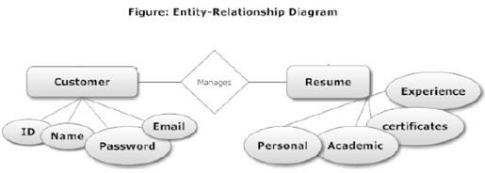

The relationship is managed by the customer and the resume in this Resume Builder. The customer carries the ID, Name, Password and Email as entities and the resume carries the Personal, Academic, Certificates, Experience as the entities.

### 

**DFD**

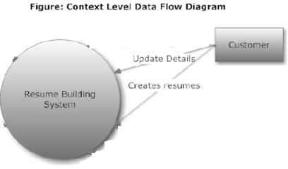

The data is flowed from the customer to the resume building system by giving the details to the system and providing a resume to the customer.

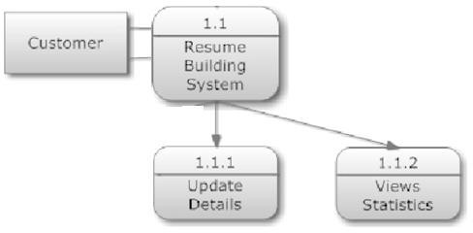

**Use Case Model**

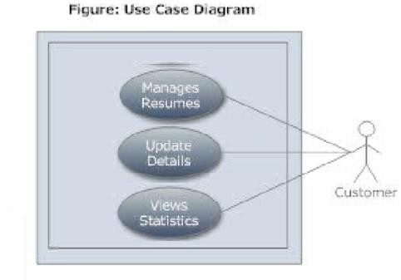

There are 3 use cases used by the customer, the use cases are directly linked with the customer. The use cases manages the resume, update the details of the customer, and allow the customer to view the statistics.

### Class diagram

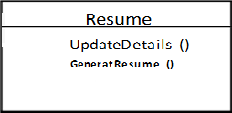

The Resume Builder contains one class in it. The name of the class is Resume and the functions of the class are UpdateDetails(), and GenerateResume().

**Component Diagram**

The server of the Resume Builder connects to the components like datasets, matplotlib, numpy and sklearn.

**datasets**

**matplotlib**

**server**

**numpy**

**sklearn**

# CHAPTER-5 IMPLEMENTATION

### MODULE & DESCRIPTION Modules

1. **User**

### Resume builder

**Modules description**

1. **User:** Users on selecting the format will be given an online form to be filled. The form includes questions like academics, personal, interests, hobbies, skills, courses, experience and so on.
2. **Resume builder:** On submitting the form the system stores the data and within a short period of time generates resume in a format

**CHAPTER 6**

**SYSTEM TESTING**

**6.1 Test Cases:**

|  |  |  |  |  |  |  |
| --- | --- | --- | --- | --- | --- | --- |
| Test ID | Test Name | Inputs | Process | Excepted Output | Actual Output | Status |
| 3 | Upload details | Name, Email, Mobile, Address, Skills 1, Skills 2, Skills 3, Skills 4, Experience 1 title, Experience 1 dur, Experience 1 desc,  Experience 2 title, Experience 2 dur, Experience 2 desc, Education 1, Education 1 dur, Education 1 score,  Education 2, Education 2 dur, Education 2 score. | Insert the details | Need to insert the | It’s inserted | Success |
| 6 | Generate resume | Select generate button | Arrange the right details | Arrange the right details | generated | Success |

# CHAPTER-7

# CONCLUSION

The project Online Resume Builder is for computerizing the working of building resumes. Resume Builder Application is really an interesting & new topic can be used by freshers or experienced persons to create resume. Using Resume Builder Application users can create a resume with standard format. A Resume Builder Application can run on any operating system of windows. It can be used by freshers or experienced persons to create a resume.

### REFERENCES

1. Catano, V. M., Wiesner, W. H., & Hackett, R. D. (2016). Recruitment and selection in Canada (6th ed.). Toronto, ON: Nelson Education Ltd.
2. Derous, E., & Ryan, A. M. (2012). Documenting the adverse impact of resume screening: Degree of ethnic identification matters. International Journal of Selection and Assessment, 20, 464-474. <https://doi.org/10.1111/ijsa.12009>
3. “Language-Check 0.8: Python Package Index,” Pypi.python.org. N.p., 2016. Web. 17 Apr. 2016.
4. Chen, C., Huang, Y., & Lee, M. (2011). Test of a model linking applicant resume information and hiring recommendations. International Journal of Selection and Assessment, 19, 374-387.

**SAMPLE CODING**

from django.shortcuts import render 2 from .forms import ContactForm 3 4 def home(request): 5 return render(request, 'home.html', {}) 6 7 def info(request): 8 form=ContactForm() 9 if request.method == 'POST': 10

form=ContactForm(request.POST) 11 if form.is_valid(): 12 name=form.cleaned_data['name'] 13

email=form.cleaned_data['email'] 14 15 skills_1=form.cleaned_data['skills_1'] 16

skills_2=form.cleaned_data['skills_2'] 17 skills_3=form.cleaned_data['skills_3'] 18

skills_4=form.cleaned_data['skills_4'] 19 20 mobile=form.cleaned_data['mobile'] 21

address=form.cleaned_data['address'] 22 23 experience_1_title=form.cleaned_data['experience_1_title'] 24

experience_1_dur=form.cleaned_data['experience_1_dur'] 25

experience_1_desc=form.cleaned_data['experience_1_desc'] 26 27

experience_2_title=form.cleaned_data['experience_2_title'] 28

experience_2_dur=form.cleaned_data['experience_2_dur'] 29

experience_2_desc=form.cleaned_data['experience_2_desc'] 30 31 education_1=form.cleaned_data['education_1']

32 education_1_dur=form.cleaned_data['education_1_dur'] 33

education1_score=form.cleaned_data['education1_score'] 34 35 education_2=form.cleaned_data['education_2'] 36

education_2_dur=form.cleaned_data['education_2_dur'] 37

education2_score=form.cleaned_data['education2_score'] 38 39 data={'name':name} 40 data['email']=email 41

data['skills_1']=skills_1 42 data['skills_2']=skills_2 43 data['skills_3']=skills_3 44 data['skills_4']=skills_4 45 46

data['mobile']=mobile 47 data['address']=address 48 49 data['experience_1_title']=experience_1_title 50

data['experience_1_dur']=experience_1_dur 51 data['experience_1_desc']=experience_1_desc 52 53

data['experience_2_title']=experience_2_title 54 data['experience_2_dur']=experience_2_dur 55

data['experience_2_desc']=experience_2_desc 56 57 data['education_1']=education_1 58

data['education_1_dur']=education_1_dur 59 data['education1_score']=education1_score 60 61

data['education_2']=education_2 62 data['education_2_dur']=education_2_dur 63 data['education2_score']=education2_score 64 return render(request,'home.html',data) 65 #to add more go to : forms.py 66 # print(name,email) 67 return render(request,'info.html',{'form':form}

**SCREENSHOTS**

**OUTPUT SCREENS**

Form to take the information of the candidate applying:

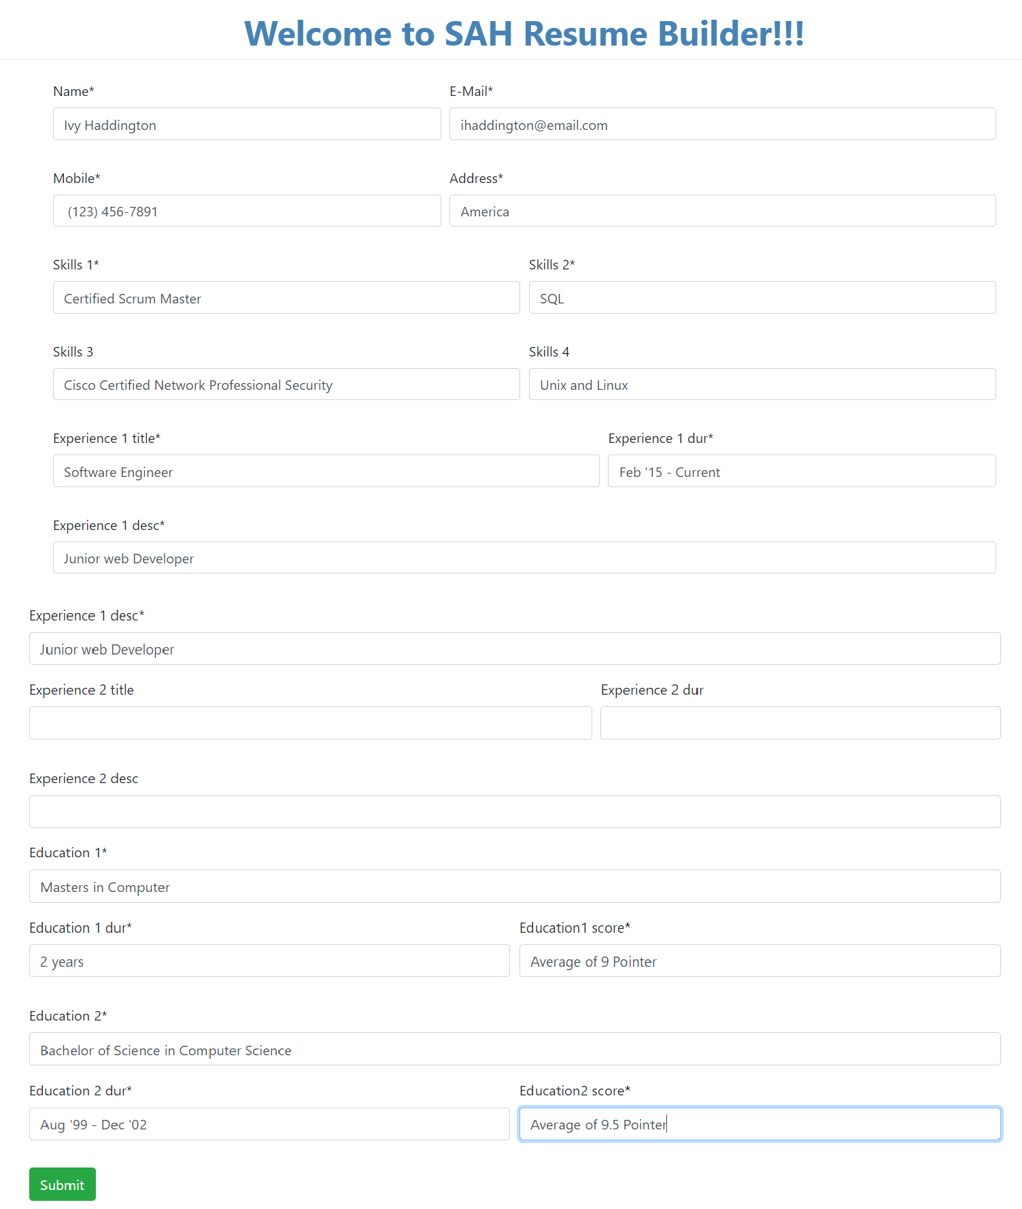

Resume generated

